Unit 3 Assignment Graded Problem Set
The digital textbook can be a little complicated to read the correct problems.
We have created this reference to help!
- Section 6.1, pages 264–265, problems 11, 17.
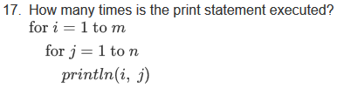
- Section 6.2, pages 278–279, problems 12, 40.
- Section 6.3, page 288, problem 9.
- Section 6.5, page 299, problems 2, 6, 18, 21.
- Section 6.6, pages 311–312, problems 15, 29, 60.

