Unit 4 Assignment Graded Problem Set
The digital textbook can be a little complicated to read the correct problems.
We have created this reference to help!
- Section 2.1, pages 70–71, problems 8, 11, 17.
- Section 2.2, pages 81–82, problems 8, 14, 33, 40, 44.
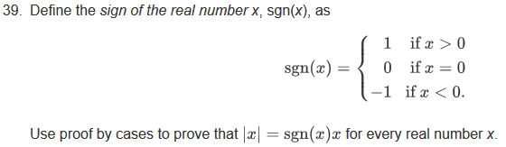
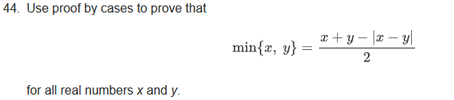
- Section 2.3, page 88, problem 6.
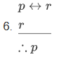
- Section 2.4, pages 96–97, problems 3, 18, 23.

