Unit 5 Assignment Graded Problem Set
The digital textbook can be a little complicated to read the correct problems.
We have created this reference to help!
- Section 4.1, page 176, problem 5.
- Section 4.2, pages 183–184, problems 5, 9, and 11.

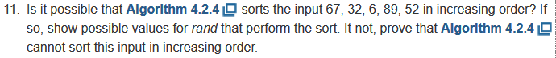
- Section 4.3, page 198, problems 2, 15, 19, 21, and 27.
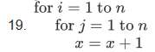
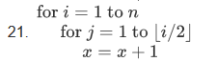
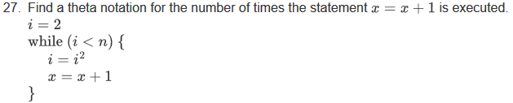
- Appendix C, page 625, problems 2, 5, and 8.
