Unit 7 Assignment Graded Problem Set
The digital textbook can be a little complicated to read the correct problems.
We have created this reference to help!
- Section 8.1, page 382, problems 3 and 10.
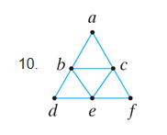
- Section 8.2, pages 392–393, problems 3, 5, 21, and 29.
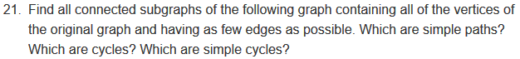
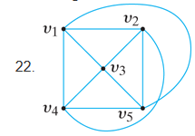
- Section 8.3, page 403, problems 5 and 7.
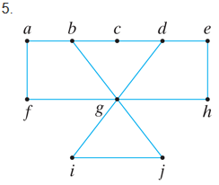
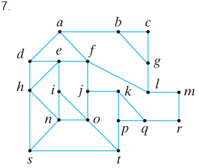
- Section 8.4, page 410, problems 2 and 7.
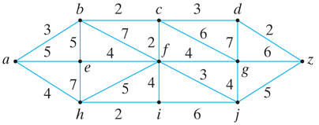

- Section 8.5, page 414, problems 3 and 9.
