Unit 8 Assignment Graded Problem Set
The digital textbook can be a little complicated to read the correct problems.
We have created this reference to help!
- Section 9.1, pages 444–445, problems 10, 16, and 28.
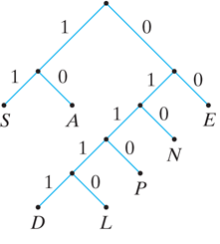
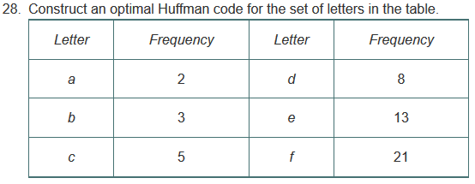
- Section 9.2, pages 449–450, problems 3, 8, and 26.
- Section 9.3, page 457, problems 3 and 9.
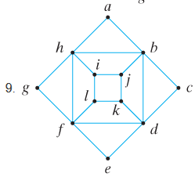
- Section 9.4, pages 463–464, problems 3 and 8.
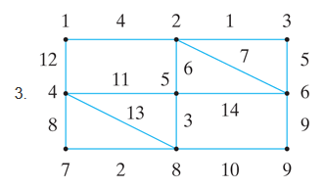
- Section 9.5, page 471, problem 2.
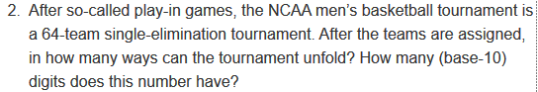
- Section 9.6, page 476, problem 3.
