Unit 9 Assignment Graded Problem Set
The digital textbook can be a little complicated to read the correct problems.
We have created this reference to help!
- Section 9.7, page 482, problem 3.
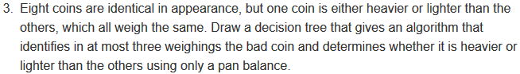
- Section 10.1, page 510, problems 2 and 8.
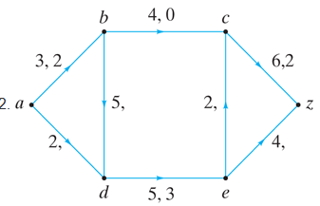
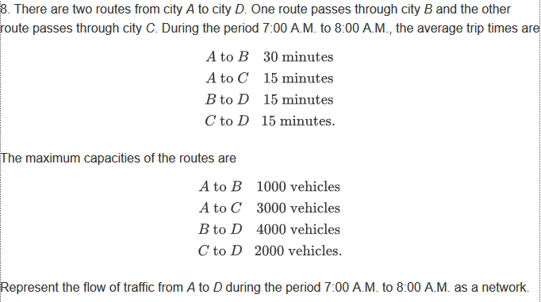

- Section 10.2, page 518, problems 2, 5, and 9.
2. 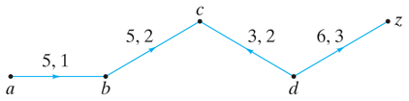
5.
9.

- Section 10.3, page 522, problems 2, 6, and 8.
2.
6.
8.
- Section 10.4, page 527, problems 2, 5, and 11
